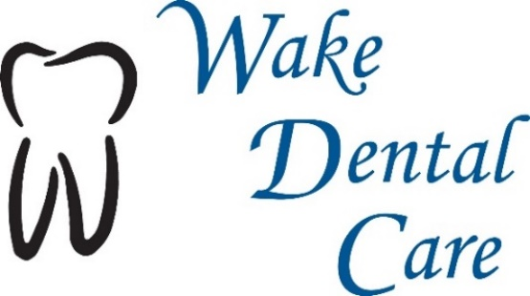
Adult Plan - $325 Annually
- Comprehensive Exam (New Patients)
- Two (2) Routine Cleanings
- Two (2) Periodic Examinations (Check-Ups)
- Any Necessary X-rays
- One (1) Fluoride Treatment
- 15% Discount on other services (Including cosmetic procedures and implants)

Adult Periodontal Plan - $550 Annually
- Comprehensive Exam (New Patients)
- Three (3) Periodontal Maintenance Cleanings
- Two (2) Periodic Examinations (Check-Ups)
- Any Necessary X-rays
- One (1) Fluoride Treatment
- 20% Discount on periodontal services including deep cleaning
- 15% Discount on other services (Including cosmetic procedures and implants)
- Note: If “alternating” with a periodontist every three months – Two (2) “Alternating” Periodontal Maintenance Cleanings ($425 Annually – includes everything else in the Adult Periodontal plan)

Child Plan (Age 14 and under) - $275 Annual
- Comprehensive exam if new patient
- Two (2) Routine Cleanings
- Two (2) Periodic Examinations
- Any Necessary X-rays
- Two (2) Fluoride Treatments
- 15% Discount on other services (sealants, fillings, etc.)

All Plans Also Include:
- 15% Membership Discount on other services including cosmetics (Exceptions – Invisalign, Whitening for Life ($149) or any treatment financed with Care Credit)
- $25 Discount for each additional Family Member. Includes spouse, dependent children through age 18 and full-time students through age 22.
- $25 Emergency Exam including one (1) Periapical X-ray if necessary ($99 Savings)
- No cosmetic exclusions, No missing tooth clause, No waiting period, No annual maximum or deductible. Our goal is to make routine dental care more affordable for our patients so that you may maintain your dental health, without the red tape of dental insurance. We hope this serves our patients as a viable alternative to dental insurance.
Membership Plan Details:
- The Annual Membership is due in full upon joining and is valid only in this office (Wake Dental Care) - it is not a traditional insurance plan.
- Payment is due for all procedures at the time of service, otherwise the 15% Membership Discount shall not apply.
- The Membership Plan is effective on the day on which the Membership Plan payment is received.
- All Annual Membership fees are non-refundable and non-transferrable.
- The discounts offered are valid only in this office and are valid from one year from the effective date.
- The Membership Plan is designed for our patients without dental insurance.
- Discounts cannot be combined with any other offers or dental insurance.
- Membership discounts do not apply to any treatment performed prior to joining.
- It is the sole responsibility of the member to maximize their benefits by arranging all appropriate appointments with in the 12 month membership period. Please schedule in advance as we cannot guarantee appointment time availability. If appointments are not used, the member will not be entitled to a refund.
- Membership Discount applies to services, not products.
- Should there be dental treatment required following any type of injury involving outside medical, auto, disability, or workman’s compensation type insurances, this discounted plan shall not be applicable.
- Reserved chair time is valuable – standard broken appointment fees ($50) shall apply if you cancel or miss your appointment with less than 48 hours notice.
- Any unused benefits shall not be refunded, credited, or carried over to the next annual period.
- Membership rates may be reviewed and adjusted on an annual basis.

I have read the above dental Membership Plan details and I agree to the terms as outlined above.
I choose the following annual plan:
_____ Adult Plan - $325
_____ Adult Periodontal Plan - $550
_____ Adult “Alternating” Periodontal Plan - $425
_____ Child Plan - $275

Effective Date: ______________________ Expiration Date: ______________________

Name (Print): __________________________ Signature: ___________________________

